Developer Guide
Outage Data Initiative Nationwide (ODIN)

Contents

Steps for implementing and sending CIM IEC 61968-3 standardized outage data 3
URLs for Test environment 3
URLs for Production environment (to be used only after successful testing) 3
Step 1: New account registration 3
Step 2: Sharing standardized outage data using CIM IEC 61968-3 7
Step 3: Send Outage Information to ODIN Securely 7
Developer Tips & Clarifications 9
CIM IEC 61968-3 Outage Examples 11
County Example 11
Zip code Example 13
Point Example 15
Polygon Example 17
MultiSpeak Outage Support 20
Example of the partial outage event message 20
Appendix A - PubOutages Profile Documentation 23
Concrete Classes 23
Abstract Classes 25
Enumerations 31
Appendix B - PubOutages Files (XSD, PNG, HTML and OWL) 33

Scope: The purpose of this guide is to provide an overall data workflow for contributing data to the Outage Data Initiative (ODIN) project. ODIN leverages two easily implementable standards for reporting electrical power outage data via Common Information Model (CIM) IEC 61968-3 and MultiSpeak.

Steps for implementing and sending CIM IEC 61968-3 standardized outage data

Before getting started: Testing is recommended and should be performed on the test environment first before sending outage information to production or https://odin.ornl.gov/. The document will refer to these environments as “test” and “production”.

URLs for Test environment
- ODIN Test website (Register account) - https://staging-odin.ornl.gov/
- ODIN Authentication/Token Test Website (POST requests only) - https://staging-odin-security.ornl.gov/oauth2/token

URLs for Production environment (to be used only after successful testing)
- ODIN Production website (Register account) - https://odin.ornl.gov/
- ODIN Authentication/Token Production Website (POST requests only) - https://production-security-odin.ornl.gov/oauth2/token

Step 1: New account registration

- Go to the ODIN website (for test or production)
- Click on “Login” button (see image at the bottom left) and then click on “Create New Account” (see image at the bottom right)
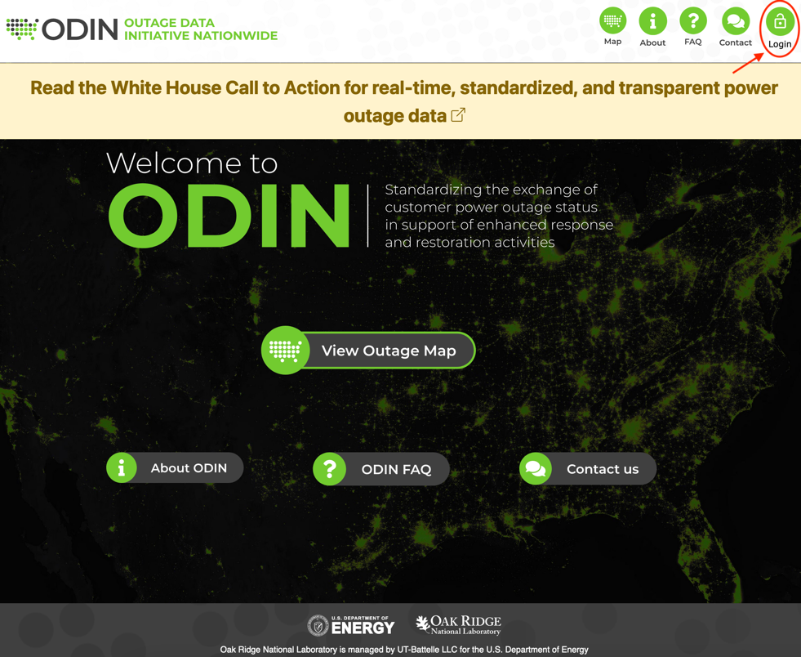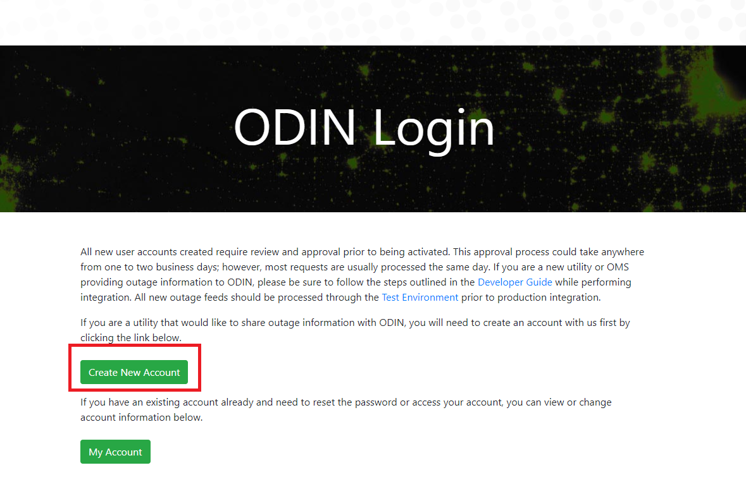

- Please provide all information requested on the form to register the account with ODIN. When completed, please click “Create Account.”

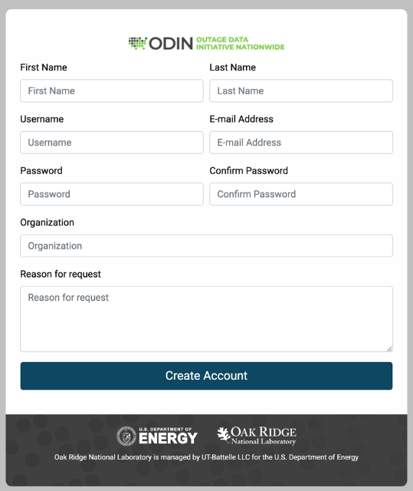

- Once the information is submitted a “User Account Created” message (see image at the bottom) will display on the screen.
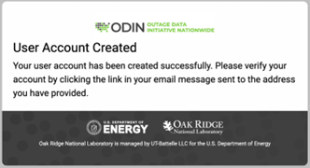

- Check your email inbox for a verification email (this will come from an account called smtp_rdseuser@ornl.gov with “ODIN” as the sender) and click on “Click Here” hyperlink to verify your address.
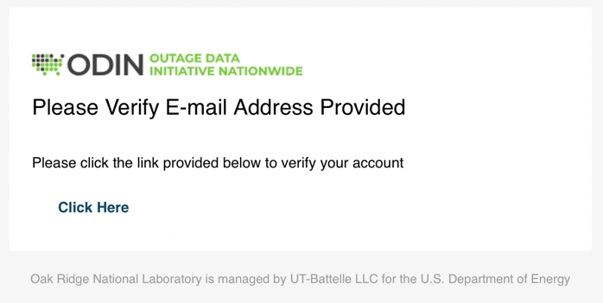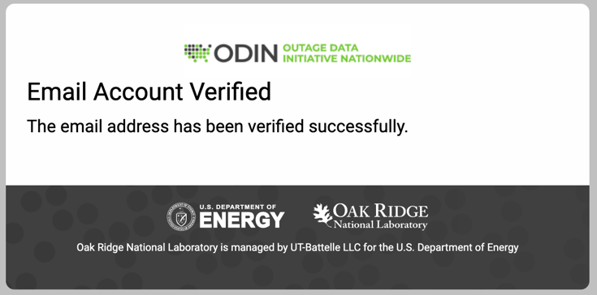

- Please allow the ODIN team 1-2 business days to review the registered account. Once the account is approved you will receive an email with further instructions on how to send outage information to ODIN.

Step 2: Sharing standardized outage data using CIM IEC 61968-3

The XSD (located in the Appendix B - PubOutages Files (XSD, PNG, HTML and OWL) can be used to generate the code. ODIN accepts standardized outage data in various granularity including county (FIPS code), zip code, and via geography information like point and polygon features if that level of detail can be provided. In addition, we provide an OpenAPI / Swagger reference page that can be used as well to generate an HTTP REST client with a tool such as Swagger CodeGen that can be used to handle this for you automatically. The OpenAPI endpoint can be viewed by going to https://odin.ornl.gov/swagger-ui/index.html on our test environment.

Please use the outage data example section as a reference.
- For example, county outage data: the “communityDescriptor” field needs a US FIPS County Code along with the number of meters affected in “metersAffected” field and the “outageAreaKind” field set to “county.” This is the minimum information that is needed to get data passed into ODIN and see if that works and go from there. We also strongly recommend that you provide ODIN an outage event identifier via the mRID which allows ODIN to track the status of the outage event and to establish the relationship between your outage management system and the outage event data provided to ODIN.

Step 3: Send Outage Information to ODIN Securely

Once your account has been approved for access, you should now be able to push outage information to ODIN using one of the accepted outage data models.

3 steps are required to request an access token and then pass that token to ODIN along with the outage request. These steps may be completed in the language or programming environment of your choice.

- Send a POST request to the ODIN Authentication/Token server for test or production environments (URLs for Test environment and URLs for Production environment) using basic authorization with the username/password that you created for ODIN.
- A basic authorization header is a base-64 encoded string that contains the “username:password” for the account, but most scripting or programming languages can also handle this natively for you as part of the HTTP request.
  - This POST will also need to include a form/URL-encoded parameter called “grant_type” with the value set to “client_credentials.” An example of what this looks like in a request is pictured below.
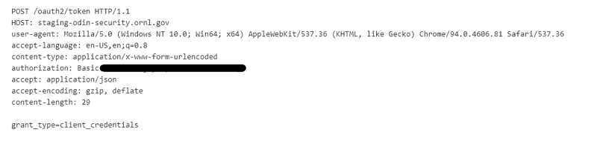
- After a POST request is sent to the authorization server, you should receive back a JSON message with a status of 200 (OK) response. The message body (which is pictured below) will contain an “access_token” property that contains your authentication credentials that will be passed to ODIN. This token is only valid and will expire after five minutes has passed by default.
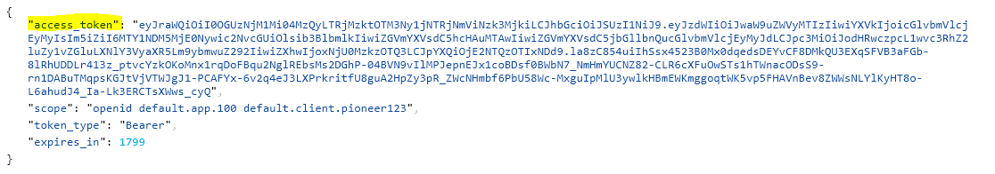
- Now, simply use HTTP POST the outage feed to ODIN (see endpoints below) at the /odin/outage endpoint in the body of the request as normal.
- Endpoints:
  - Test environment: https://staging-odin.ornl.gov/odin/outage
  - Production environment: https://odin.ornl.gov/odin/outage
- Header:
  - Include an authorization header in the request and set the header to be of type “Bearer” followed by a space and the complete access token that was provided to you in the previous step
  - Set ‘Content-Type’: ‘application/xml’
  - Update data: Currently, the ODIN backend will replace all existing data provided by a utility with the next set of data provided (data is not appended to existing data)
  - Clear data if there are no outages: Posting an empty xml request will clear all existing data for a utility
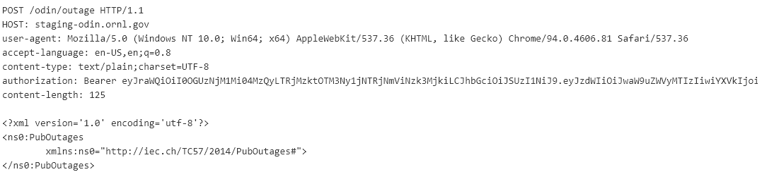

Developer Tips & Clarifications
- mRID (unique to each outage instance)
  - A unique outage instance id must be sent using the mRID attribute.
  - The mRID should be used as an ID to track the outage event. This information could come from the outage tracking identifier that is used in the Outage Management Software (OMS). We use this identifier to describe the outage event and track the status of the outage event over time.
- Utility Name
  - A utility name must be sent using the name attribute.
  - While uniqueness is preferred, utility name is not required to be unique. The utility name reported to the U.S. Energy Information Administration (EIA) is recommended. If you do not know your utility’s EIA utility name, visit the EIA website and review the latest annual report, you may contact the ODIN team.
- Utility ID (must be unique on the ODIN system)
  - A unique utility id must be sent using the name attribute. The utility ID is mapped to utility number published in the EIA-861 form. If you do not know your utility’s EIA Utility ID, please contact ODIN team.
  - If a utility ID is not sent on the feed, then ODIN can assign your unique EIA utility number for your utility.
- Causes
  - The CIM standard has enumerations for outage causes.
  - ODIN allows data in a string format for cause due to the wide variety of causes outside the CIM standard.
- Times and Dates
  - The CIM standard requires a specific time/date format. ODIN recommends ISO-8601 format. All time should be reported in UTC.
  - ODIN currently allows time data in a string format due to time/date format variance across utility outage reporting.

CIM IEC 61968-3 Outage Examples

County Example

<?xml version="1.0" encoding="UTF-8"?>
<ns0:PubOutages xmlns:ns0="http://iec.ch/TC57/2014/PubOutages#">
<ns0:Outage>
<ns0:mRID>EXAMPLE-OUTAGE-UNIQUE-ID</ns0:mRID>
<ns0:communityDescriptor>County Identifier (will take precedence over geoInfoReference but only FIPS code is allowed in this field)</ns0:communityDescriptor>
<ns0:cause>Cause of Outage</ns0:cause>
<ns0:causeKind>Event Kind to Cause Outage</ns0:causeKind>
<ns0:metersAffected>7</ns0:metersAffected>
<ns0:outageKind>outageReported</ns0:outageKind>
<ns0:reportedStartTime>2021-02-06T14:27:07.1228664Z</ns0:reportedStartTime>
<ns0:statusKind>Current Status Kind for Outage</ns0:statusKind>
<ns0:utilityDisclaimer>Utility Disclaimer Text</ns0:utilityDisclaimer>
<ns0:actualPeriod>
<ns0:start>2021-02-06T14:27:07.1228664Z</ns0:start>
</ns0:actualPeriod>
<ns0:EstimatedRestorationTime>
<ns0:ert>2021-02-06T16:30:00Z</ns0:ert>
</ns0:EstimatedRestorationTime>
<ns0:OutageArea>
<ns0:metersServed>100</ns0:metersServed>
<ns0:outageAreaKind>county</ns0:outageAreaKind>
</ns0:OutageArea>
<ns0:Incident>
<ns0:cause>Pending Investigation</ns0:cause>
<ns0:Location>
<ns0:geoInfoReference>12345</ns0:geoInfoReference>
<ns0:zoneKind>county</ns0:zoneKind>
</ns0:Location>
</ns0:Incident>
<ns0:Names>
<ns0:name>ENTER UTILITY ID (preferably from EIA)</ns0:name>
<ns0:nameType>UtilityID</ns0:nameType >
<ns0:nameTypeAuthority>Source for name information (preferably EIA)</ns0:nameTypeAuthority>
</ns0:Names>
<ns0:Names>
<ns0:name>ENTER UTILITY Name (preferably from EIA)</ns0:name>
<ns0:nameType>UtilityName</ns0:nameType>
<ns0:nameTypeAuthority>Source for name information (preferably EIA)</ns0:nameTypeAuthority>
</ns0:Names>
</ns0:Outage>
</ns0:PubOutages>

Zip code Example

<?xml version="1.0" encoding="UTF-8"?>
<ns0:PubOutages xmlns:ns0="http://iec.ch/TC57/2014/PubOutages#">
<ns0:Outage>
<ns0:mRID>EXAMPLE-OUTAGE-UNIQUE-ID</ns0:mRID>
<ns0:communityDescriptor>Zip code Identifier (will take precedence over geoInfoReference but only zip code is allowed in this field)</ns0:communityDescriptor>
<ns0:cause>Cause of Outage</ns0:cause>
<ns0:causeKind>Event Kind to Cause Outage</ns0:causeKind>
<ns0:metersAffected>7</ns0:metersAffected>
<ns0:outageKind>outageReported</ns0:outageKind>
<ns0:reportedStartTime>2021-02-06T14:27:07.1228664Z</ns0:reportedStartTime>
<ns0:statusKind>Current Status Kind for Outage</ns0:statusKind>
<ns0:utilityDisclaimer>Utility Disclaimer Text</ns0:utilityDisclaimer>
<ns0:actualPeriod>
<ns0:start>2021-02-06T14:27:07.1228664Z</ns0:start>
</ns0:actualPeriod>
<ns0:EstimatedRestorationTime>
<ns0:ert>2021-02-06T16:30:00Z</ns0:ert>
</ns0:EstimatedRestorationTime>
<ns0:OutageArea>
<ns0:metersServed>100</ns0:metersServed>
<ns0:outageAreaKind>zipcode</ns0:outageAreaKind>
</ns0:OutageArea>
<ns0:Incident>
<ns0:cause>Pending Investigation</ns0:cause>
<ns0:Location>
<ns0:geoInfoReference>92357</ns0:geoInfoReference>
<ns0:zoneKind>zipcode</ns0:zoneKind>
</ns0:Location>
</ns0:Incident>
<ns0:Names>
<ns0:name>ENTER UTILITY ID (preferably from EIA)</ns0:name>
<ns0:nameType>UtilityID</ns0:nameType >
<ns0:nameTypeAuthority>Source for name information (preferably EIA)</ns0:nameTypeAuthority>
</ns0:Names>
<ns0:Names>
<ns0:name>ENTER UTILITY Name (preferably from EIA)</ns0:name>
<ns0:nameType>UtilityName</ns0:nameType>
<ns0:nameTypeAuthority>Source for name information (preferably EIA)</ns0:nameTypeAuthority>
</ns0:Names>
</ns0:Outage>
</ns0:PubOutages>

Point Example

<?xml version="1.0" encoding="UTF-8"?>
<ns0:PubOutages xmlns:ns0="http://iec.ch/TC57/2014/PubOutages#">
<ns0:Outage>
<ns0:mRID>EXAMPLE-OUTAGE-UNIQUE-ID</ns0:mRID>
<ns0:communityDescriptor>Description of the community</ns0:communityDescriptor>
<ns0:cause>Cause of Outage</ns0:cause>
<ns0:causeKind>Event Kind to Cause Outage</ns0:causeKind>
<ns0:metersAffected>7</ns0:metersAffected>
<ns0:outageKind>outageReported</ns0:outageKind>
<ns0:reportedStartTime>2021-02-06T14:27:07.1228664Z</ns0:reportedStartTime>
<ns0:statusKind>Current Status Kind for Outage</ns0:statusKind>
<ns0:utilityDisclaimer>Utility Disclaimer Text</ns0:utilityDisclaimer>
<ns0:actualPeriod>
<ns0:start>2021-02-06T14:27:07.1228664Z</ns0:start>
</ns0:actualPeriod>
<ns0:EstimatedRestorationTime>
<ns0:ert>2021-02-06T16:30:00Z</ns0:ert>
</ns0:EstimatedRestorationTime>
<ns0:OutageArea>
<ns0:metersServed>100</ns0:metersServed>
<ns0:outageAreaKind>SERVICE_AREA</ns0:outageAreaKind>
</ns0:OutageArea>
<ns0:Incident>
<ns0:cause>Pending Investigation</ns0:cause>
<ns0:Location>
<ns0:PositionPoints>
<ns0:sequenceNumber>1</ns0:sequenceNumber>
<ns0:xPosition>0</ns0:xPosition>
<ns0:yPosition>0</ns0:yPosition>
</ns0:PositionPoints>
</ns0:Location>
</ns0:Incident>
<ns0:Names>
<ns0:name>ENTER UTILITY ID (preferably from EIA)</ns0:name>
<ns0:nameType>UtilityID</ns0:nameType >
<ns0:nameTypeAuthority>Source for name information (preferably EIA)</ns0:nameTypeAuthority>
</ns0:Names>
<ns0:Names>
<ns0:name>ENTER UTILITY Name (preferably from EIA)</ns0:name>
<ns0:nameType>UtilityName</ns0:nameType>
<ns0:nameTypeAuthority>Source for name information (preferably EIA)</ns0:nameTypeAuthority>
</ns0:Names>
</ns0:Outage>
</ns0:PubOutages>

Polygon Example

<?xml version="1.0" encoding="UTF-8"?>
<ns0:PubOutages xmlns:ns0="http://iec.ch/TC57/2014/PubOutages#">
<ns0:Outage>
<ns0:mRID>EXAMPLE-OUTAGE-UNIQUE-ID</ns0:mRID>
<ns0:communityDescriptor>Description of the community</ns0:communityDescriptor>
<ns0:cause>Cause of Outage</ns0:cause>
<ns0:causeKind>Event Kind to Cause Outage</ns0:causeKind>
<ns0:metersAffected>7</ns0:metersAffected>
<ns0:outageKind>outageReported</ns0:outageKind>
<ns0:reportedStartTime>2021-02-06T14:27:07.1228664Z</ns0:reportedStartTime>
<ns0:statusKind>Current Status Kind for Outage</ns0:statusKind>
<ns0:utilityDisclaimer>Utility Disclaimer Text</ns0:utilityDisclaimer>
<ns0:actualPeriod>
<ns0:start>2021-02-06T14:27:07.1228664Z</ns0:start>
</ns0:actualPeriod>
<ns0:EstimatedRestorationTime>
<ns0:ert>2021-02-06T16:30:00Z</ns0:ert>
</ns0:EstimatedRestorationTime>
<ns0:OutageArea>
<ns0:metersServed>100</ns0:metersServed>
<ns0:outageAreaKind>SERVICE_AREA</ns0:outageAreaKind>
</ns0:OutageArea>
<ns0:Incident>
<ns0:cause>Pending Investigation</ns0:cause>
<ns0:geoInfoReference>Name/Id for the location provided</ns0:geoInfoReference>
<ns0:Location>
<ns0:PositionPoints>
<ns0:sequenceNumber>1</ns0:sequenceNumber>
<ns0:xPosition>0</ns0:xPosition>
<ns0:yPosition>0</ns0:yPosition>
</ns0:PositionPoints>
<ns0:PositionPoints>
<ns0:sequenceNumber>2</ns0:sequenceNumber>
<ns0:xPosition>1</ns0:xPosition>
<ns0:yPosition>0</ns0:yPosition>
</ns0:PositionPoints>
<ns0:PositionPoints>
<ns0:sequenceNumber>3</ns0:sequenceNumber>
<ns0:xPosition>1</ns0:xPosition>
<ns0:yPosition>1</ns0:yPosition>
</ns0:PositionPoints>
<ns0:PositionPoints>
<ns0:sequenceNumber>4</ns0:sequenceNumber>
<ns0:xPosition>0</ns0:xPosition>
<ns0:yPosition>1</ns0:yPosition>
</ns0:PositionPoints>
<ns0:PositionPoints>
<ns0:sequenceNumber>5</ns0:sequenceNumber>
<ns0:xPosition>0</ns0:xPosition>
<ns0:yPosition>0</ns0:yPosition>
</ns0:PositionPoints>
</ns0:Location>
</ns0:Incident>
<ns0:Names>
<ns0:name>ENTER UTILITY ID (preferably from EIA)</ns0:name>
<ns0:nameType>UtilityID</ns0:nameType >
<ns0:nameTypeAuthority>Source for name information (preferably EIA)</ns0:nameTypeAuthority>
</ns0:Names>
<ns0:Names>
<ns0:name>ENTER UTILITY Name (preferably from EIA)</ns0:name>
<ns0:nameType>UtilityName</ns0:nameType>
<ns0:nameTypeAuthority>Source for name information (preferably EIA)</ns0:nameTypeAuthority>
</ns0:Names>
</ns0:Outage>
</ns0:PubOutages>

MultiSpeak Outage Support

The ODIN project team can pull outage information from systems that support MultiSpeak protocol version 4 and later with the capability to pull outage information from the method call “GetAllActiveOutageEvents” periodically through pull mechanism.
The required data fields are “customersAffected”, “customersRestored”, “GPSLocation”, “startTime” and other fields like “outageCause” are encouraged, but optional. If you would like ODIN to connect to your system and pull this outage information from your MultiSpeak service, please contact the project team.

For the connection to work properly, we will need to know the following information about your service:
- ODIN will need a publicly available web service endpoint or URL that can be reached to get outage events.
- Username/password information to connect to the system if the service endpoint is password protected.
- Any special considerations regarding the confidentiality of the information provided by your service? For example, should ODIN hide any details with regards to where the outages are occurring?
- How frequently (in minutes) can ODIN poll outage information available from your service to get updates? Generally, ODIN pulls data every 5-10 minutes.

Example of the partial outage event message

<?xml version="1.0" encoding="UTF-8"?>
<outageEvent objectID="%eventId%">
<comments>%eventComments%</comments>
<extensionsList>
<extensionsItem>
<extName>primaryCrew</extName>
<extValue>Primary Crew Name</extValue>
<extType>string</extType>
</extensionsItem>
</extensionsList>
<objectName>%eventName%</objectName>
<GMLLocation>
<coord xmlns="gml_V4.1_Release">
<X>%gmlX%</X>
<Y>%gmlY%</Y>
</coord>
</GMLLocation>
<GPSLocation GPSValidity="true">
<latitude>%latitude%</latitude>
<longitude>%longitude%</longitude>
</GPSLocation>
<gridLocation>TRANSFORMER1</gridLocation>
<area>District9</area>
<problemLocation>TRANSFORMER1</problemLocation>
<deviceID name="TRANSFORMER1" noun="transformerBank" objectID="%deviceId%" utility="" />
<deviceType>Transformer</deviceType>
<outagedPhase>A</outagedPhase>
<substationCode>10</substationCode>
<feeder>FeederName</feeder>
<outageStatus>Assumed</outageStatus>
<startTime>%startTime%</startTime>
<firstDispatch>%firstDispatch%</firstDispatch>
<ETOR>%etor%</ETOR>
<completed />
<crewsDispatched>
<crewID>Crew1</crewID>
</crewsDispatched>
<customersAffected>%numAffected%</customersAffected>
<priorityCustomersCount>0</priorityCustomersCount>
<ODEventCount>1</ODEventCount>
<customersRestored>%numRestored%</customersRestored>
<outageReasonCodeList>
<outageCause>
<description>Contractor</description>
<outageReportingCodeList>
<outageReportingCode reportingBody="Utility Defined">44</outageReportingCode>
</outageReportingCodeList>
</outageCause>
<outageCause>
<description>Fallen Limb</description>
<outageReportingCodeList>
<outageReportingCode reportingBody="Utility Defined">44</outageReportingCode>
</outageReportingCodeList>
</outageCause>
</outageReasonCodeList>
</outageEvent>

Appendix

Appendix A - PubOutages Profile Documentation
Profile namespace: http://iec.ch/TC57/2014/PubOutages#

Concrete Classes
Outage
Native Members
mRID | 1..1 | string | Master resource identifier issued by a model authority. The mRID can be used as an ID to track the outage event. This information could come from the outage tracking identifier that is used in the Outage Management Software (OMS). We use this identifier to describe the outage event and track the status of the outage event over time.
cause | 0..1 | string | The cause of this outage. This is the cause that is used to present to external entities. That is, the cause is weather, equipment failure, etc.  Note: At present, this is a free text; could be replaced with a separate associated class in case we have multiple causes (e.g., OutageCauseType, inheriting from IdentifiedObject).
causeKind | 0..1 | OutageCauseKind
communityDescriptor | 0..1 | string
customersRestored | 0..1 | integer
metersAffected | 0..1 | integer
originalCustomersServed | 0..1 | integer
originalMetersAffected | 0..1 | integer
outageKind | 0..1 | OutageStatusKind | Defines if the outage has been verified or is only estimated.
reportedStartTime | 0..1 | dateTime | The earliest start time of the Outage - as reported by some system or individual.  Datetime should be in ISO-8601 format and reported in UTC.
statusKind | 0..1 | CrewStatusKind
utilityDisclaimer | 0..1 | string
actualPeriod | 0..1 | DateTimeInterval
estimatedPeriod | 0..1 | DateTimeInterval
EstimatedRestorationTime | 0..1 | EstimatedRestorationTime | Datetime should be in ISO-8601 format and reported in UTC.
Incident | 0..unbounded | Incident | Incident reported in trouble call that results in this outage.
Names | 1..unbounded | Name | All names of this identified object.
OutageArea | 0..unbounded | OutageArea

Abstract Classes
CoordinateSystem - coordinate reference system.
Native Members
crsUrn | 1..1 | string | A Uniform Resource Name (URN) for the coordinate reference system (crs) used to define 'Location.PositionPoints'.  An example would be the European Petroleum Survey Group (EPSG) code for a coordinate reference system, defined in URN under the Open Geospatial Consortium (OGC) namespace as: urn:ogc:def:uom:EPSG::XXXX, where XXXX is an EPSG code (a full list of codes can be found at the EPSG Registry web site http://www.epsg-registry.org/). To define the coordinate system as being WGS84 (latitude, longitude) using an EPSG OGC, this attribute would be urn:ogc:def:uom:EPSG::4236.  A profile should limit this code to a set of allowed URNs agreed to by all sending and receiving parties.

EstimatedRestorationTime - the Estimated Restoration Time (ERT) for a single outage
Native Members
confidenceKind | 1..1 | ERTConfidenceKind | provides the confidence level that this ERT can be accomplished. This may be changed/updated as needed.
ert | 1..1 | dateTime | estimated time the outage will be restored.  Datetime should be in ISO-8601 format and reported in UTC.
ertSource | 1..1 | string | defines the source that provided the ERT value.

Incident - Description of a problem in the field that may be reported in a trouble ticket or come from another source. It may have to do with an outage.
Native Members
cause | 1..1 | string | Cause of this incident.
Location | 1..1 | Location | Location of this incident.

Location - the place, scene, or point of something where someone or something has been, is, and/or will be at a given moment in time. It can be defined with one or more position points (coordinates) in a given coordinate system.
Native Members
direction | 1..1 | string | (If applicable) Direction that allows field crews to quickly find a given asset. For a given location, such as a street address, this is the relative direction in which to find the asset. For example, a streetlight may be located at the 'NW' (northwest) corner of the customer's site, or a usage point may be located on the second floor of an apartment building.
geoInfoReference | 1..1 | string | (If applicable) Reference to geographical information source, often external to the utility.
kind | 0..1 | ZoneKind | Kind of this zone.
type | 1..1 | string | Classification by utility's corporate standards and practices, relative to the location itself (e.g., geographical, functional accounting, etc., not a given property that happens to exist at that location).
CoordinateSystem | 1..1 | CoordinateSystem | Coordinate system used to describe position points of this location.
PositionPoints | 1..unbounded | PositionPoint | Sequence of position points describing this location, expressed in coordinate system 'Location.CoordinateSystem'.

Name - The Name class provides the means to define any number of human readable names for an object. A name is not to be used for defining inter-object relationships. For inter-object relationships instead use the object identification 'mRID'.

Native Members
name | 1..1 | string | Any free text that names the object.  For ODIN, this field is used twice, once for Utility ID and once for Utility Name.
NameType | 0..1 | NameType | Type of this name.  For ODIN, this field is used twice, once as ‘UtilityID’ and once as ‘UtilityName’.

NameType - Type of name. Possible values for attribute 'name' are implementation dependent but standard profiles may specify types. An enterprise may have multiple IT systems each having its own local name for the same object, e.g., a planning system may have different names from an EMS. An object may also have different names within the same IT system, e.g., localName as defined in CIM version 14. The definition from CIM14 is: The localName is a human readable name of the object. It is a free text name local to a node in a naming hierarchy similar to a file directory structure. A power system related naming hierarchy may be Substation, VoltageLevel, Equipment etc. Children of the same parent in such a hierarchy have names that typically are unique among them.

Native Members
description | 0..1 | string | Description of the name type.  The source of the Name.name attribute -- that is the Utility, EIA, NERC, or some other entity.
name | 0..1 | string | Name of the name type.  The source of the Name.name attribute -- that is the Utility, EIA, NERC, or some other entity.
NameTypeAuthority | 0..1 | NameTypeAuthority | Authority responsible for managing names of this type.

NameTypeAuthority - Authority responsible for creation and management of names of a given type; typically an organization or an enterprise system.

Native Members
description | 0..1 | string | Description of the name type authority.  A description of the entity that assigns and maintains the Name.name
name | 0..1 | string | Name of the name type authority.  This is the name of the entity that maintains and uses the Name.name identifier - normally this would be the Utility

OutageArea - This defines the area covered by the Outage.
Native Members
earliestReportedTime | 1..1 | dateTime | This is the reported time of the first outage report.  Datetime should be in ISO-8601 format and reported in UTC.
metersServed | 1..1 | integer | defines the number of meters served in the defined area.
outageAreaKind | 1..1 | AreaKind | defines the type of area that has the outage - county, state, zip code, etc.

PositionPoint - Set of spatial coordinates that determine a point, defined in the coordinate system specified in 'Location.CoordinateSystem'. Use a single position point instance to describe a point-oriented location. Use a sequence of position points to describe a line-oriented object (physical location of non-point-oriented objects like cables or lines), or area of an object (like a substation or a geographical zone - in this case, have first and last position point with the same values).

Native Members
sequenceNumber | 1..1 | integer | Zero-relative sequence number of this point within a series of points.
xPosition | 1..1 | string | X axis position.  For this message, this is the Latitude
yPosition | 1..1 | string | Y axis position.  For this message, this is the Longitude
zPosition | 1..1 | string | (if applicable) Z axis position.

Enumerations
AreaKind - Enumeration for the type of area defined; e.g., county, state, parish, zip code, etc.
borough
county
parish
serviceArea
state
township
ward
zipcode
tract

CrewStatusKind - the enumerated values for the dispatch status
arrived | Indicates that one or more crews have arrived at the work site
assigned | Indicates that one or more crews have been assigned to the work
awaitingCrewAssignment | Indicates that the work is awaiting one or more crews to be assigned
enroute | Indicates that one or more crews are traveling to the work site(s)
fieldComplete | Indicates that the work at one or more work sites has been completed

ERTConfidenceKind - The estimated time of restoration can have a confidence factor applied such as high or low confidence that the ERT will be accomplished. This confidence factor may be updated as needed during the outage period - just as the actual ERT can be updated.
high | there is a high confidence that the ERT will be accomplished
low | there is a low confidence that the ERT will be accomplished.

OutageCauseKind - This enumeration describes the primary cause of the outage - planned, unplanned, etc.
animal | This outage was caused by an animal was unplanned. As such it is treated as a forced outage and is probably classified as "trouble" with a Trouble Ticket as well as a work/service order. The primary difference between this and an unplanned outage is the reason for the outage. If an animal caused this and perished as a result, the utility may have other actions that are required to be taken by the EPA or other groups with whom the utility has an agreement.
lightingStrike
lineDown
poleDown
treeDown

Compound Types - Interval between two date and time points.
Members
end | 1..1 | dateTime | End date and time of this interval.
start | 1..1 | dateTime | Start date and time of this interval.

Appendix B - PubOutages Files (XSD, PNG, HTML and OWL)

PubOutages XSD | PubOutages Hierarchy (PNG) | PubOutages Information HTML | CIMedit / CIM editing software
XSD | PNG | HTML | CIMedit

The mRID, or master resource identifier, should be unique to each outage event and used to track the status of the outage event.
geoInfoReference for ODIN should be FIPS code but can also be a county name if the FIPS is already provided in the community descriptor.
UtilityID can be a unique identifier defined by the utility, or preferably, it is the unique identifier used by EIA for reporting.
UtilityName can be a unique identifier defined by the utility, or preferably, it is the unique identifier used by EIA for reporting.
The mRID, or master resource identifier, should be unique to each outage event and used to track the status of the outage event.
geoInfoReference will be superseded by community descriptor if community descriptor is also provided. Also, for ODIN geoInfoReference should be zip code if the zip code is already provided in the community descriptor.
This is the FIPS code or ZIP code for the outage area. The type of code must be specified under zoneKind. For NISC utilities, ZIP code must be used.
UtilityID can be a unique identifier defined by the utility, or preferably, it is the unique identifier used by the Energy Information Administration for reporting.
UtilityName can be a unique identifier defined by the utility, or preferably, it is the unique identifier used by the Energy Information Administration for reporting.
The mRID, or master resource identifier, should be unique to each outage event and used to track the status of the outage event.
UtilityID can be a unique identifier defined by the utility, or preferably, it is the unique identifier used by EIA for reporting.
UtilityName can be a unique identifier defined by the utility, or preferably, it is the unique identifier used by EIA for reporting.
The mRID, or master resource identifier, should be unique to each outage event and used to track the status of the outage event.
UtilityID can be a unique identifier defined by the utility, or preferably, it is the unique identifier used by EIA for reporting.
UtilityName can be a unique identifier defined by the utility, or preferably, it is the unique identifier used by EIA for reporting.

